

**ZANZIBAR INSTITUTE OF BUSINESS, RESEARCH AND TECHNOLOGY**

**(ZIBRET)**

**DEPARTMENT OF INFORMATION AND COMMUNICATION TECHNOLOGY**

**PROJECT REPORT**

**ACADEMIC YEAR 2016-2018**

**PROJECT’S TITLE: ONLINE PATIENT MANAGEMENT SYSTEM**

**STUDENT NAME: MOHAMMED ALI ALI**

**REGISTRATION NUMBER: ZIBRET/ DICT/2016/003**

**NAME OF SUPERVISOR: Mr. ABDALLAH HAJI FAKI**

**SUBMISSION DATE 14th February 2018**

**DECLARATION.**

***I am Mohamed Ali Ali (ZB/DICT/2016/0003) hereby*** declares the undergraduate student in the department information communication technology (ICT) at Zanzibar Institute of Business Research and Technology(ZIBRET); this report is the result of my effort and my own work. I am sure that no one submitted this report as same as my report in any University, college or institute

Student signature: ……………………………… Date ……/…../…….

Supervisor’s signature: ........................................ Date ……/…../…….

# **ACKNOWLEDGMENT**

First and for most I would like to thank Allah the almighty who has strengthen me to do this Project.

Secondly, I would like to thank my supervisor Mr.ABDALLAH HAJI FAKI for giving me moral support and assistance during the entire period while doing this project.

Also, I would like to thank the teaching staff of ZANZIBAR INSTITUTE OF BUSINESS RESEARCH AND TECHNOLOGY especially those of information technology department for giving us relevant knowledge that helped me in creating this project and in my studies.

Finally, I would also like to thank my fellow students, family members, friends and others for giving me moral support and assistance. Without them I would never have made it here, so thank you so much.

# **ABSTRACT**

The main purpose of developing PATIENT MANAGEMENT SYSTEM (PMS), life is becoming too busy to get medical appointments in person and to maintain a proper health care.

The main idea of this work is to provide easy and comfort to patients while taking appointment from doctors and it also resolves the problems that the patients has to face making an appointment while he/she is at home. The Patient Management System uses the database containing the doctor’s details, patient’s details and appointment details is maintained by a website that acts as a server.

# **TABLE OF CONTENT**

Table of Contents

**DECLARATION.** ii

**ACKNOWLEDGMENT** i

**ABSTRACT** ii

**TABLE OF CONTENT** iii

**TABLE OF FIGURES** iv

**CHAPTER 1: INTRODUCTION** 1

**1.0** **BACKGROUND** 1

**1.1 PROBLEM STATEMENT** 1

**1.2 PROJECT MAIN AIM** 1

**1.3 PROJECT SPECIFIC OBJECTIVES** 1

**1.4 EXPECTED RESULTS** 2

**1.5 LITERATURE REVIEW** 2

**1.6 REPORT LAYOUT** 3

**CHAPTER 2: FEASIBILITY STUDY** 4

**2.0 STUDY AREA** 4

**2.1 FEASIBILITY STUDY** 4

**2.1.1Technical** 4

**2.1.2Operational** 4

**2.1.3Economical** 4

**2.2 REQUIREMENT ELICITATION** 5

**2.3 REQUIREMENT SPECIFICATION** 5

**2.3.1FUNCTIONAL REQUIREMENT** 5

**2.3.2NON-FUNCTIONAL REQUIREMENT** 5

**2.4 ANALYSIS** 6

**CHAPTER 3: METHODOLOGY** 7

**3.0 METHODOLOGY** 7

**3.1 ARCHITECTURE** 7

**3.2 DATABASE DESIGN** 8

**3.3 PROCESSES DESIGN** 8

**3.3.1Data Flow Diagram** 8

**CHAPTER 4: IMPLEMENTATION AND TESTING** 10

**4.0 Implementation** 10

**4.1 Testing** 10

**4.2 Validation testing** 10

**CHAPTER 5: USER MANUAL** 12

**5.0 User Manual** 12

**5.1 Login Page** 12

5.2 Administrator’s Interface 13

**CHAPTER 6: CHALLENGES and RECOMMENDATIONS** 17

**6.0 Challenges** 17

**6.1 Recommendations** 18

**IMPLEMENTED CODE BEHIND** 18

**REFERENCES** 20

# **TABLE OF FIGURES**

Figure 1 PRESENTAION OF THREE TIER ARCHITECTURE 7

Figure 2: ERD DIAGRAM FOR THE CONTAINER LEASE INFORMATION SYSTEM 8

Figure 3: Data Flow Diagram FOR Online Health Care System( LEVEL 1) 9

Figure 5: LOGIN TESTING WITHT SUSPENDED USER ACCOUNT 10

Figure 6: LOGIN WITH WRONG DETAILS OF USER 11

Figure 7: LOGIN FORM 12

Figure 8: ADMIN USER REGISTRATION INTERFACE 13

Figure 9:LIST OF REGISTERED USERS 14

Figure 10:EDIT USER FORM 15

Figure 16:SAMPLE OF Add Appointment 16

# **CHAPTER 1: INTRODUCTION**

## **BACKGROUND**

According to the research I conducted there was no system that works the same as my proposed system. So I generate this idea after analysing there are some kinds of problems in health service which can be solved easily in computerized form.

If anybody is ill and wants to visit a doctor for check-up, he or she needs to visit the hospital and waits until the doctor is available. The patient also waits in a quiet while getting appointment. If the doctor cancels the appointment for some emergency reasons then the patient is not able to know about the cancelation of the appointment unless or until he or she visits the hospital.

## **1.1 PROBLEM STATEMENT**

At present if anybody is ill and wants to visit a doctor for check-up, he or she needs to visit the hospital and waits until the doctor is available. The patient also waits in a queue while getting appointment. If the doctor cancels the appointment for some emergency reasons then the patient is not able to know about the cancelation of the appointment unless or until he or she visits the hospital.

## **1.2 PROJECT MAIN AIM**

Generally, the main aim of this project is to create a web base system that will allow patient (customer) to set up an appointment with doctors respectively with their hospitals.

## **1.3 PROJECT SPECIFIC OBJECTIVES**

* Studying the current manual appointment and find out its problems.
* Collecting all needed requirements through Interview and reviewing of forms
* Designing and implementing database and user interface of PATIENT MANAGEMENT SYSTEM and Implementing and testing the proposed system by the most reliable tools php and MySQL Server.

## **1.4 EXPECTED RESULTS**

* The system will expect to solve the problem arise and hence many advantages will be achieved.
* Each patient (customer) will have only one accession ID number as his/her primary key.
* It will ensure security of doctors and patients information.
* System administration will register all doctor before they sign up
* Cost effectiveness and easy data access.
* We are expecting that the system will be in user friend interface.

## **1.5 LITERATURE REVIEW**

According to literature review I conducted there was no similar system implemented in Zanzibar hence this was the first idea I generated hopefully will be implemented.

What I have done on this I tried to collect information from some doctors from different hospital to understand what kind of information they are required to provide to their hospital as there record needed.

Also I took some advices from different people/patient on how they explain their problems to the specified doctor and how it should be easy for them to interact with the system.

## **1.6 REPORT LAYOUT**

The report contains six chapters which explain different related things about the proposed system these chapters including; Chapter one that hold an introduction part together with background, Problem statement which explain the main problem facing the organization, Project main aim and Project specific objectives, Expected results that customers are expecting after accomplishment of the project, Literature review which talks about the theoretical review and operational review and Report layout.

Chapter two is the second chapter in this report which contains the Study area that involve the place where the project requirement was collected, Feasibility study, Requirement elicitation which describe the possible ways used to collect data for the project, Requirement specification and Analysis.

Chapter three is the third chapter in this report which contains Design of the project, Methodology used for the implementation of the project, Architecture of the project, Database design and Processes design.

Chapter four is the fourth chapter in this report which shows the Implementation part and Testing to show how well the system was implemented and tested before being installed and used.

Chapter five is the fifth chapter in this report that explain the User manual that shows the user how to use the system in a simplified way.

Chapter six is the last chapter that explain the challenges faced by the students during the whole time of implementation and Recommendations the system and university respectively.

# **CHAPTER 2: FEASIBILITY STUDY**

## **2.0 STUDY AREA**

The Environment in which we are working on involves all hospitals located in Zanzibar in whereby they are providing health services to their patient with different treatment according to the hospital it offers.

## **2.1 FEASIBILITY STUDY**

Under the consideration of the types of feasibility study, the investigations in feasibility study phase had been undertaken through various steps which are described as follows:-

* Ascertain the origin of the information at different level.
* Identify the expectation of user from computerized system.
* Examines the drawback of existing system (manual) system.

### **2.1.1 Technical**

In this I have assess the current resources (such as hardware and software) and technology, which are mostly required to accomplish user requirements in the software (system) within the allocated time and budget. This become successful since the hardware which are going to be used to develop the system fits our budget as well as the software. The hardware include computer with at least 4GB RAM, 500GB of hard disk and i3 processor along with printer for printing out materials. Software include

### **2.1.2 Operational**

I do expect and hope that the operation and handling of the Zanzibar Electronic Health Services Information System is highly accurate, and the system will be the best solution concerning the followings:-

* **Performance:** the system will provide accuracy work and will be easy to use.
* **Efficiency:** the system makes maximum use of available resources that includes people, time, flow of forms, minimum processing delays and the like.
* **Information:** the system provides users with timely, pertinent, accurate, and usefully formatted information.

### **2.1.3 Economical**

It has been realized that the system is economically feasible by considering money the system will not cost so much, though too much time is required to develop the system.

Also running the system, training the users in how to use the system and the system maintenance is possible.

## **2.2 REQUIREMENT ELICITATION**

Requirements elicitation is the process of collecting the **requirements** of a system from users, customers and other stakeholders. The process is also sometimes referred to as "**requirement gathering**".

Eventually, two ways have been used in obtaining data from the users of the system, these including;

* Interview: it involve the face-to-face conversation with the doctors and patients in which note were taken while talking with the doctors and asked different questions verbally in which the method was a great help in obtaining data from the users.
* Document review: fortunately there were bundle of documents of the correspondent business which were reviewed and widening the knowledge and understand how the system should look like so as to reach the user expectations.

## **2.3 REQUIREMENT SPECIFICATION**

Requirements specification is a description of a software system to be developed. It lays out functional and non-functional requirements which are described below:-

### **2.3.1 FUNCTIONAL REQUIREMENT**

These functions specify the behaviour of the system or how the system should be functioning. These include the following:-

* The system will have the administrative functions
* The system will be able to show authorization level
* The system will be able to generate reports
* The system will update users’ and customer’s appointment information

### **2.3.2 NON-FUNCTIONAL REQUIREMENT**

The non-functional requirement specify how the system should behave i.e. It specify the quality attribute of the system. These will include the following:-

* The system should have better performance.
* It should be reliable.
* The system should be secure.
* It must maintain data integrity.
* It should be user friendly.

## **2.4 ANALYSIS**

After the collection of requirements and data gathering it came to be realised that there are so many processes which are involved in leasing containers since it contain the cargo inside it but the main target of our is just the container therefore, the system will only covers the scope where container leased until it returned to the company excluding the cargo

# **CHAPTER 3: METHODOLOGY**

## **3.0 METHODOLOGY**

The methodology used in the system development was Structured Methodology(SM)

And the model used was “Prototyping model”. This model has so many advantages over other types of models which are listed below:-

* Users are actively involved in the development
* Since in this methodology a working model of the system is provided, the users get a better understanding of the system being developed.
* Errors can be detected much earlier.
* Quicker user feedback is available leading to better solutions.
* Missing functionality can be identified easily
* Confusing or difficult functions can be identified

## **3.1 ARCHITECTURE**

The architecture design for the Container Lease Information System is based on the three-tier architecture. This three-tier architecture mainly consists of three layers namely:

* Application Server: Tier converts and displays information into a human legible form. This Tier displays information related to services such as viewing containers etc. It communicates with the other tiers by outputting results to the client tier and all the other tiers.
* Client Application: Business Logic tier is mainly responsible for information exchange between the user interface and the database of the project.
* Data Source Tier: The final layer of the three tiered architecture is the Data Access tier, which mainly consists of the Database servers. The information related to the Container Lease Information System is stored and retrieved from here.

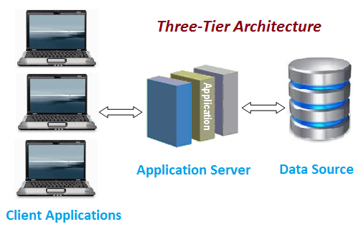A simple representation of the three-tier architecture would be as follows:

Figure 1 PRESENTAION OF THREE TIER ARCHITECTURE

## **3.2 DATABASE DESIGN**

Database design is the process of producing a detailed data model of database. This data model contains all the needed logical and physical design choices and physical storage parameters needed to generate a design in a data definition language, which can be used to create a database. As far as container lease information system is concern the following ERD has been produced which is shown as follows.

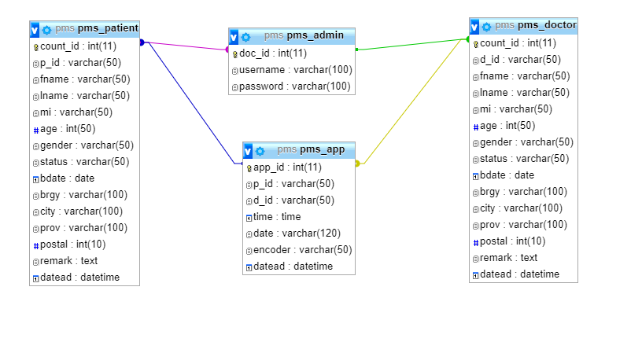

Figure 2: ERD DIAGRAM FOR THE CONTAINER LEASE INFORMATION SYSTEM

## **3.3 PROCESSES DESIGN**

Process design involve the activity of determining the workflow, equipment needs, and implementation requirement for the project. Typically there are number of tools involved that has been used to design the process. In the proposed system the design used was objected oriented where use case, class diagram and sequence diagrams have been used.

### **3.3.1 Data Flow Diagram**

A Data Flow diagram is a data flow diagram that shows how the data how flows within the system inserted by system users.

**Symbols used**

**ENTITY**: is the one who interact with the system

**DATA FLOW**: shows the relationships how data flow within the systems.

**PROCESS**: shows processes within the system.

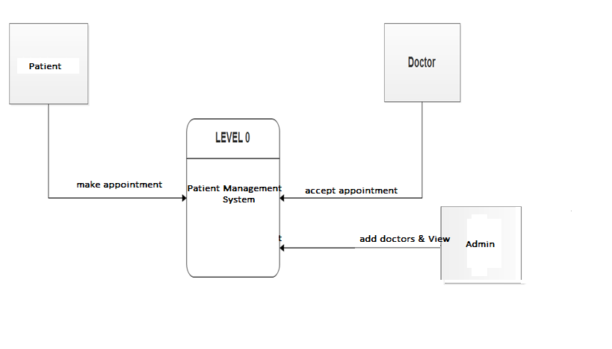**DATABASE**: Stores all information needed for the system

Figure 3: Data Flow Diagram FOR Online Health Care System( LEVEL 1)

# **CHAPTER 4: IMPLEMENTATION AND TESTING**

## **4.0 Implementation**

Implementation is the phase through which the theory turn to practical. All the designs and other requirements are turned into useful code so as to obtain a complete system that will work efficiently. In the part of the proposed system (Patient Management System) the tools used for implementation was Xamp that contains Server to run PHP programming for the code behind of implementation and MySQL for database design and storage. Additionally, CSS, Bootstrap and Adobe Photoshop have been used for the interface decoration.

## **4.1 Testing**

In this phase number of system testing have been performed to ensure the accuracy of the system since this phase is the most important one if there is any mistake or error it will be identified during testing. The testing that have been performed was validation.

## **4.2 Validation testing**

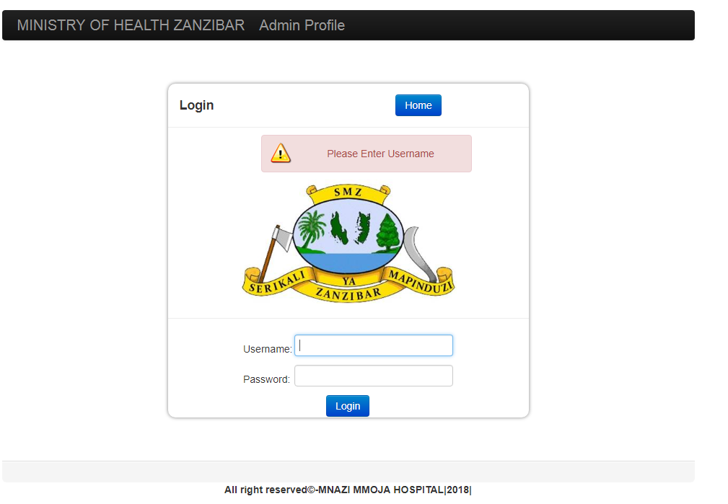In this testing there are some validates which have been used in the system to ensure that Container Lease Information System reach to the stated goal of developing a secured web-based system. To ensure its competencies Required Field Validator, Compare Validator and Verification have been used as shown in the following figures.

Figure 5: LOGIN TESTING WITHT SUSPENDED USER ACCOUNT

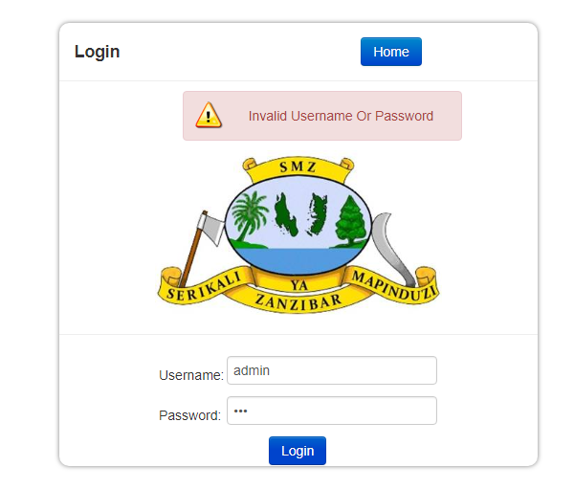

Figure 6: LOGIN WITH WRONG DETAILS OF USER

# **CHAPTER 5: USER MANUAL**

## **5.0 User Manual**

In this portion is where the full direction and procedure of the usage of the system is explained. Different screen shorts of the system will be shown as it operates show the users how to use the system.

## **5.1 Login Page**

This is the key page of the system, it enables users of the system to log in into the system.

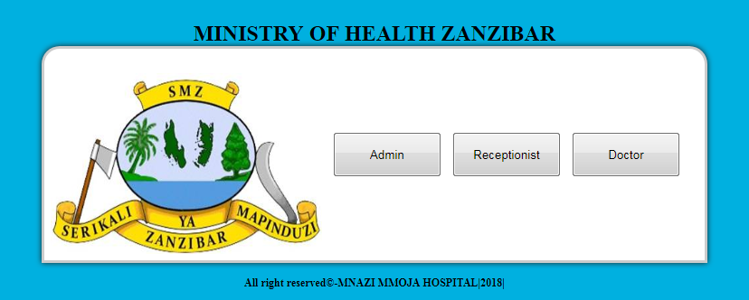For each user he/she must login with his/her given username and password. The system will enrol THREE types of users they are Administrator, Doctor and Receptionist. And for each type will have its own interface.

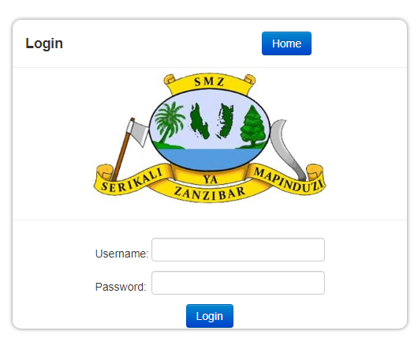

Figure 7: LOGIN FORM1.2 Administrator’s & Receptionist’s Interface

This is the first page that the Administrator sees once he logged in. In this page is where he will be able to user registration process for doctors and patients which he will provide a unique ID for each User.

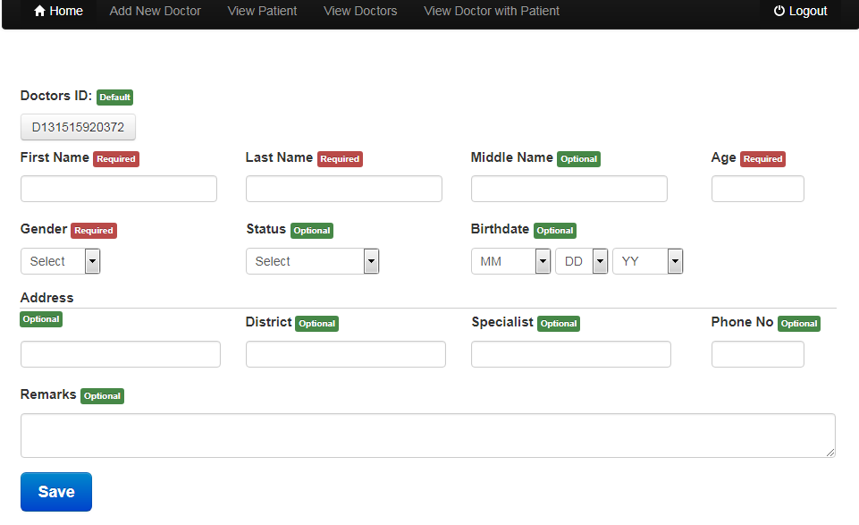

Figure 8: ADMIN USER REGISTRATION INTERFACE

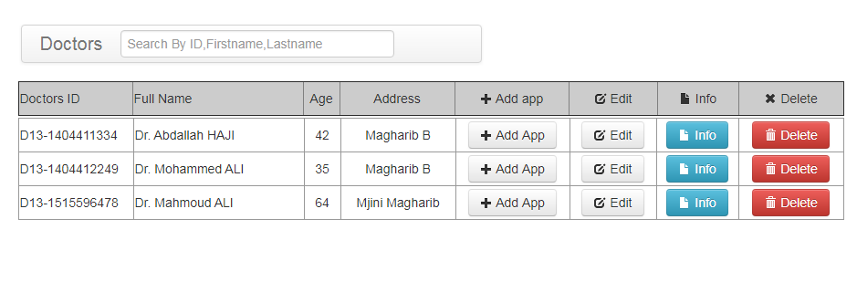View the All Registered User details just click on the “View User” as shown in the pictures

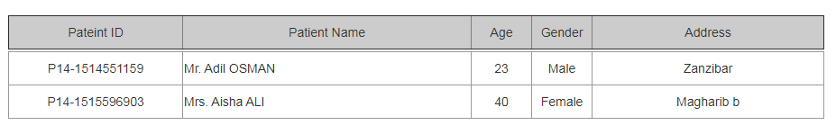

Figure 9:LIST OF REGISTERED Doctor and Patient

To edit any User information if there has been any mistake, from the side button “edit” list click on the “Edit” link, once you click the bellow page will appear from there you will be able to edit finally 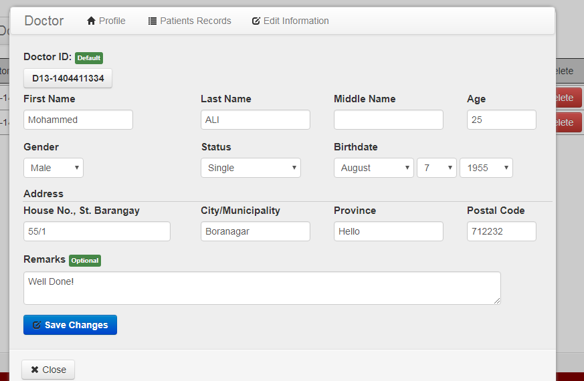click “Update User”.

Figure 10:EDIT USER FORM

Add Appointment

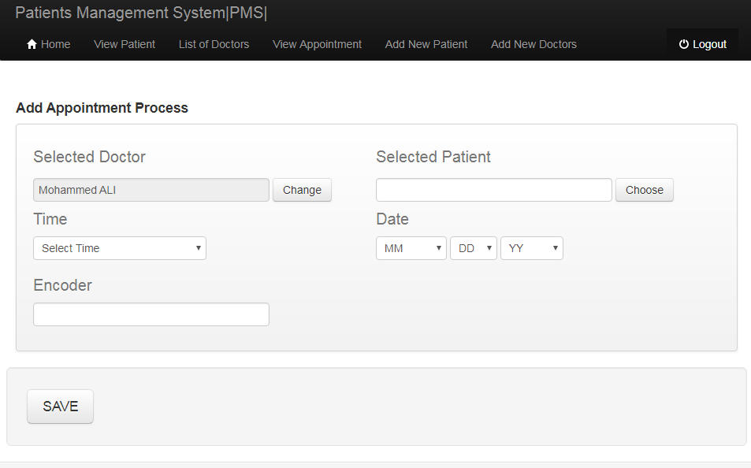

Figure 16:SAMPLE OF Add Appointment

# **CHAPTER 6: CHALLENGES and RECOMMENDATIONS**

## **6.0 Challenges**

During the development we faced a lot of problems and difficulties .Implementation period (phase) was a bit tough than others in following manner.

* **Debugging and Suggestions**

This part of implementation of a system was a bit harder a result a lot of time we spend there. Not only that even suggestions from external and advice from supervisor, which makes several changes of the system in order to produce good software. Difficulties we faced here, was challenge of making a changes over and over.

* **Lack of reviews for referencing**

In some ways we faced problem of having documented materials relevant to Patient Management System such as books and articles. Most of the relevant materials were available Online only in which it gets harder to reviews them at the time with no internet connections.

* **Resources Limitations**

University does not have enough facilities that can support students in their project development.

For instance free available rooms or computer laboratories where students can use within particular time without any intervention.

* **Financial Supporting**

We have been experienced with financial problems across the project development from the startto the end, such as cost for attaining internet bundles for modem connections also cost in delivery of System which is required to be in hard copy and soft copy whereby it cost a lot in terms of printing system documentation.

## **6.1 Recommendations**

On the side of recommendations we recommend that the university should teach the student in term of practical’s oriented than theory especial computer sciences and IT so as to produce a competent students compare to other university.

1. Time management is critical important in a university and should considered and give priority so as to schedule the task and not to overload the students with a lot of task concurrently.
2. The last semester students of university of Zanzibar (SUZA) in computer science and IT should participate on one course only project and removing all other course in the last semester.
3. It’s more batter for the university to teach one programming language from scratch and continuing with the next three semesters.
4. Also we recommend that the university should comply with the current technology that widely used for all students of computing in all levels.

# **IMPLEMENTED CODE BEHIND**

**Log In codes:**

**<!----- INCLUDE HEAD SCRIPT --->**

**<?php include_once 'includes/head.php';?>**

**<body>**

**<div class="wrapper">**

**<!------- NAVIGATION INCLUDE ---->**

**<?php include_once 'includes/nav.php';?>**

**<div class="login-div">**

**<div class="modal-header">**

**<h3>Login</h3>**

**</div>**

**<div class="body">**

**<div id="login_status" style="width:94%"></div>**

**<div style="width:223px;padding-top:10px; margin:auto;">**

**<!--- Check Session Is Set Or Not -->**

**<?php if(!isset($_SESSION['doc_id']) && empty($_SESSION['doc_id'])):?>**

**<form method="post”>**

**<fieldset>**

**<label>Username :</label>**

**<input type="text" name="username" id="username" />**

**<label>Password :</label>**

**<input type="password" name="password" id="password" />**

**<table border="0">**

**<td><a href="javascript:void(0);" class="vpb_general_button btn btn-primary" style="float: left;" onclick="doLogin();">Login</a></td>**

**</table>**

**</fieldset>**

**</form> <!--login forms-->**

**<?php else: echo header("Location:dashboard.php"); endif;?>**

**</div>**

**</div> <!-- body -->**

**<div class="modal-footer"></div> <!--- modal footer --->**

**</div> <!-- login div -->**

**<div class="clear">&nbsp;</div>**

**</div>**

**</body>**

**</html>**

# **REFERENCES**

* Scott Sehlhorst, 2016. Non Functional Requirements List. [Online] Retrieved from <http://tynerblain.com/blog/non-functional-requirements-list/>
* StackOverFlow, (2017) How to get difference between year. Retrieved from <https://stackoverflow.com/questions/4748323/how-to-find-year-and-month-difference-between-two-dates>
* Boostrap (n.d). Properties for Design. Retrieved from

<http://getbootstrap.com/2.3.2/index.html>

* CodeImplementation (n.d). LoginCode. Retrieved from

<https://www.youtube.com/>